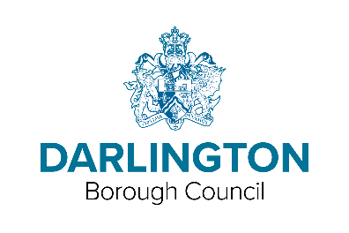

LOW INCIDENCE NEEDS SERVICE REQUEST FORM

This form is for requesting involvement from the Low Incidence Needs Service at Hurworth Primary school. The attached Parent/Carer consent section must be completed.

What Service do you require? (Please tick )
Hearing Impairment | Vision Impairment
Physical Needs Advisor

School Details
Setting/school: |  | Tel No:
Email:
SENCo: |  | Class Teacher:  Key worker:
Sen Register / SEN Support / One Plan / EHC  (please circle all that apply) |  |  | Year Group:

Child / Young Person Details:
Name:  Preferred name: | DOB: | Sex: M F
Address: |  | Post code:
NHS Number:
Name of Parent/Carer:
Contact Number(s):
In Local Authority Care? | Yes | No

Reasons for referral (continue on additional sheets if required)

Nature of Impairment / Physical Disability / Diagnosis?

What are your current concerns? Reason for Referral?
Other agencies involved currently?
e.g. Paediatrician, Consultants, Speech and Language Therapy, Occupational Therapy, Physiotherapy, Early Years Inclusion Service, etc. Please provide names & contact numbers if possible.

Medical Information (MUST BE completed if requesting HI or VI service)

Hospital:
Consultant:
Details of impairment (if known):

Completed by: |  | Date:
Position:

Email:

Please complete and attach the Parents’/Carers’ consent form (below) and return all pages to:

Low Incidence Needs Service
Hurworth Primary School
Westfield Drive
Darlington
DL2 2ET
Telephone: 01325 720033

Parent/Carer Consent Form for the Low Incidence Needs Service

I agree to the involvement of the following service/s: (Please tick )
Hearing Impairment | Vision Impairment
Physical Needs Advisor

Child/Young Person Details
Name of child/young person: | DOB: | Sex: M / F
Address: |  | Post code:
Contact Number(s):
Email Address:

Please tell us about your child’s needs:

I agree to the involvement of the Low Incidence Needs Service (Please tick )
Yes | No
I agree that advice or information about my child can be sought from and shared with other agencies involved with my child. (Please tick )
Yes | No
I agree for my child to be seen in their education setting without parental presence. (Please tick )
Yes | No

Signed: | Date:
Print Name: | Relationship to child:
Please return the completed form to
Low Incidence Needs Service
Hurworth Primary School
Westfield Drive
Darlington
DL2 2ET

Telephone: 01325 720033

