

**Hurworth Primary School**

**Behaviour Policy**

|  |  |
| --- | --- |
| **Policy Version Control** | |
| Policy type | Hurworth Primary School |
| Policy prepared by (name and designation) | Alison Maddison  Headteacher |
| Last review date | September 2022 |
| Description of changes/Updates | * Change of Team Hurworth rewards to be included in Steps to Success * Addition of Physical Intervention * Rewording of sections |
| LGB approval |  |
| Date released | September 2023 |
| Next review date | September 2024 |

**Introduction**

At Hurworth Primary School, we feel it is important to promote a caring and supportive environment to allow all members of the school community to feel secure, respected and therefore promote good behaviour in others, allowing all children to achieve their full potential. Our school is committed to creating an environment where exemplary behaviour is at the heart of productive learning. We can achieve this through a bedrock of kindness and strong relationships across school. Everyone is expected to maintain the highest standards of personal conduct, to accept responsibility for their behaviour and encourage others to do the same. Our school motto, ‘Consider, Create, Contribute,’ is at the heart of everything we do at Hurworth Primary. Aligned to this are our six values which are interwoven through our curriculum policies and everyday practice.

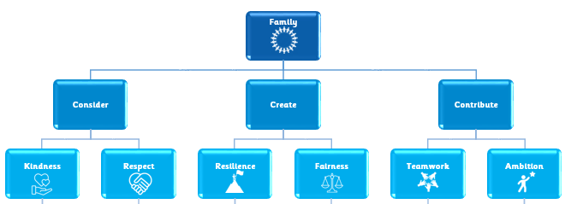

**Aims**

* To develop a whole school behaviour policy supported and followed by the whole school community (parents, teachers, children and governors) based on a sense of community and shared values.
* To apply consistent expectations and guidance to create a caring, purposeful and happy family atmosphere in which teaching and learning can take place in a safe and happy environment.
* To ensure that all children are treated fairly and shown respect, and to promote strong relationships and foster positive, caring attitudes towards everyone.
* To teach, through the school curriculum, values and attitudes as well as knowledge and skills. This will promote responsible behaviour, encourage self-discipline and encourage in children a respect for themselves, for other people and for property. This will be done throughout the curriculum but particularly in PSHE.
* To help children take control over their behaviour and be responsible for the consequences of it.
* To highlight and promote models of good behaviour by providing a range of rewards for children of all ages and abilities.
* To ensure safety by making boundaries of acceptable/appropriate behaviour clear, ensuring the distinction between minor and more serious incidents and the range of consequences that will follow is made clear to children.
* To treat problems when they occur in a caring and sympathetic manner to improve behaviour.
* To develop a sense of belonging and pride in the Hurworth family.
* To ensure that our children recognise their own personal development and mental health as a priority.
* To build a community which values kindness, respect, resilience, fairness, teamwork and ambition.

**School Ethos**

The adults in our school family have an important role to model high standards of behaviour at all times. As adults, the expectation is that we:

* demonstrate respect for everyone;
* create a positive climate with realistic expectations;
* emphasise the importance of being valued as an individual;
* promote, through example, honesty and courtesy;
* provide a caring and effective learning environment;
* encourage relationships based on kindness, respect and understanding of the needs of others;
* ensure fair treatment for all regardless of age, gender, race, ability and disability;
* show appreciation of the efforts and contribution of all.

It is our belief that there is a very clear link between high quality teaching and learning and good behaviour. Children who are suitably challenged and engaged are less likely to present with challenging behaviours. For this reason, our behaviour policy should be read in conjunction with our Curriculum Intent Statement and Special Educational Needs policy.

**Hurworth Behaviour Principles**

We recognise that strong relationships, consistent routines and positive reinforcement have the best impact on behaviour. Our behaviour principles set out the rules, routines and visible consistencies that all children and staff follow. Our principles are based on the work of Paul Dix and his book, ‘When the Adults Change, Everything Changes’. Good behaviour is recognised sincerely through the class recognition board alongside individual and team rewards. Adults notice and reward excellent behaviour that goes ‘Above and Beyond’. Children are praised publicly and reprimanded in private.

**Rules**

Our school has three simple rules which can be applied to a variety of situations and are taught and modelled explicitly:

* Be ready: I will help myself and others to learn.
* Be respectful: I will respect the building, staff and other children.
* Be safe: I will look after myself and others.

At the start of each academic year, the class teacher will revisit the school rules and teach how the children can demonstrate positive behaviour in and around school in order to create a calm, happy, safe environment.

**Visible Adult Consistencies**

Children thrive on a sense of belonging, consistency and routine. As such, we have clear routines and expectations at the centre of our behaviour approach, setting the tone from the second that the children and families arrive at school.

We understand that a common and consistent use of language around behaviour is essential in creating clear boundaries and expectations around how to behave well. Discussions around behaviour should remain professional at all times. It is expected that any member of staff uses consistent language as set out in our microscripts. Conversations around behaviour should be conducted, in the first instance, by the member of staff present or by a member of the Leadership Team.

Our consistent routines and expectations are:

* Consistent arrivals (Detailed in appendix 1)
* Fantastic walking (Detailed in appendix 1)
* Lining up (Detailed in appendix 1)
* Lunchtimes (Detailed in appendix 1)
* Moving around school (Detailed in appendix 1)
* Gaining attention (Class Stop) (Detailed in appendix 3)
* Constantly referring to our 3 school rules and ‘The Hurworth Way’ (See appendix 2)
* Consistent reward and recognition
* Consistent adult language and approach to behaviour
* Individual classroom routines (See appendix 3)

**Behaviour Guidelines**

Our behaviour guidelines are clearly defined and consistently applied, whilst recognising the individual needs of our children. We teach children about making the right choices regarding their behaviour and to take responsibility for their actions and consequences. We encourage and reward positive behaviour and discourage behaviour that does not reflect our school values, ethos and expectations.

**Rewards**

Children like rewards, and adults enjoy giving them, but they must be well-timed, appropriately earned and meaningful to the child. Staff will pay first attention to the best conduct and will endeavour to catch children ‘doing the right thing’ in order to praise and recognise desired behaviours. This encourages children to be role models and makes expectations on behaviour clear for all. Rewards should not be used disproportionality for a child who finds behaving more of a challenge; we should never overlook the children who always ‘do the right thing’, whilst working hard with the children who struggle to do this. Details of how to address behaviours which we do not accept, is detailed in the ‘Unacceptable Behaviour’ section’ below.

The primary reward in our school is simple – it is a genuine smile, a thank you, a well done, an ‘I’m proud of you’. When relationships are genuine and warm, kind words mean the world to children and adults alike. Well-placed and appropriate praise permeates throughout our school family. Of course, we also reward individuals in variety of more formal and public ways too:

|  |
| --- |
| **Individual Rewards** |
| Steps to Success |
| Our individual reward system rewards positive behaviours and attitudes to learning alongside demonstrating our school values. It consists of stamps and Steps to Success stickers. Stickers may be given for demonstrating one particular value or for a specific piece of work, or may be earned by collecting 10 stamps. 20 stickers earns a certificate.  Steps to Success stickers are handed to the children in all areas of the school for:   * Demonstrating our school values * Good behaviour in and out of the classroom (e.g. in the hall during assemblies, working at tables,  sitting on the carpet) * Wonderful independent, paired or group work * Fantastic contributions and responses * Smart and quiet lining up * Eating with good table manners * Demonstrating fantastic walking * Being polite and showing courtesy to others * Being helpful * Playing cooperatively * Being a good friend * Good behaviour when out in the community   The system is cumulative so as the child moves through the school they progress through a series of certificates: colours of the rainbow, metallics, gems and planets. These certificates are presented in our celebration assembly on a Friday. |
| Above and Beyond Recognition - Wows |
| We must recognise the children who go ‘Above and Beyond’ the school expectations and do more than simply follow the rules of the school. Children who stand out at a particular time for doing something special will receive recognition for this.  When any adult in school sees a child going ‘Above and Beyond’, they must recognise it and reward it with a Wow.  If a child goes ‘Above and Beyond’ throughout the day, they will receive a Wow text that will be sent to their parents/carers and will detail what the Wow was for so that parents/carers can celebrate the children’s success.  Individual children should not receive several of these each week; they are special and highly regarded. |
| Pupil of the Week |
| Each week, teachers nominate a Pupil of the Week for demonstrating excellence in relation to any of the school’s six core values. This award is earned and given on merit and a child may be awarded it more than once during the year.  In the celebration assembly, each class teacher gives a small speech explaining why the child has achieved the nomination in relation to one of our six core values or sub-traits. They then receive a certificate and small prize from the member of the SLT. |
| Above and Beyond Recognition - Certificate |
| Where a child has gone ‘above and beyond’ and demonstrated all six of our core values, they will receive an ‘Above and Beyond Certificate’ which will be presented in our celebration assembly. The Head Teacher will give a small speech explaining why the child has achieved the nomination in relation to our six core values or sub-traits. |
| Governors’ Awards |
| At the end of each year, a Governors’ Award is given to one child from each class who has been an exemplary role model and embodies the school motto, ‘Consider, Create and Contribute’. Each child receives a book token and a shield. |
| Additional Recognition |
| There is also a special recognition award for one Year 6 child who has demonstrated the school values and ethos throughout their time at school and has embodied our school motto. This child is chosen through nominations by all members of school staff. They receive a book token and shield and their name is engraved on a shield which is displayed in school.  Staff also nominate a Head Boy and Head Girl from Year 5 who have demonstrated our core values throughout their time at school. They are chosen as they embody our school motto and are seen as exemplary role models. As part of their role, the children will be given many opportunities to represent the school throughout the following academic year. |

The power of the group is at the heart of our behaviour principles, where adults notice and reward excellent behaviour as a group in the following ways:

|  |
| --- |
| Team Rewards |
| Class Recognition Board |
| There is a recognition board in every classroom. These may look different in each classroom, but promote our school motto: ‘Consider, Create, Contribute’.  Each class will have a current focus linked to the needs of the class. It may be an improvement in lining up, transitioning to independent work more quickly, taking responsibility for tidying up their resources etc.  The teacher and children decide on these foci and when they are changed.  When a child is doing the right thing, their name is added to the recognition board. Once it is on, it cannot be removed. When all the names are on the board, the class have proven that they can all do it and if they are not, they are choosing not to. There should be a celebratory ‘Hip Hip Hooray’. It is a big deal and should be made to feel as such. To celebrate the class’ achievement, a Wow text is sent home (see below) and children receive 5 minutes of additional break time. |
| Above and Beyond Recognition - Wows |
| We must also recognise that the whole class or a group of children can go ‘Above and Beyond’ the school expectations. In such circumstances, the class or group will receive a Wow text that will be sent to their parents/carers and will detail what the Wow was for so that parents/carers can celebrate the children’s success. |

Importantly, there will be no other formal awards created by staff. Consistency across the school is key. We do not create ‘special rewards’ for children who struggle to behave, unless this agreed with the Headteacher. It makes them special in relation to their poor behaviours, and we are then rewarding the child inappropriately. We may agree to this following involvement of an educational psychologist, for example. Simple stickers and stamps for doing a ‘good job’ or taking an active part in a session are fine.

**Strategies to Develop Excellent Behaviour**

* IDENTIFY the behaviour we expect
* Explicitly TEACH behaviour
* MODEL the behaviour we are expecting
* PRACTISE behaviour
* NOTICE excellent behaviour
* CREATE conditions for excellent behaviour

**Unacceptable Behaviour**

In a primary school, children are not only learning to read, write and count; they are also learning to behave. At times, children will require their choice of behaviour to be checked, or addressed.

When addressing unacceptable behaviour, staff will be calm, consistent and fair in their treatment of children and colleagues. Adults in school will not shout at children or become emotionally charged. They will model self-control through their calm approach and will deal with individuals fairly.

Before embarking on the behaviour pathway, it is vital that the adult stops and considers:

* How would I speak to this child if their parent was on my shoulder?
* What would the best teacher in the world do?
* It is my professional responsibility to stay calm; I need to be mindful of my tone, body language and intonation

**Behaviour Pathway**

1. Reminder
2. Final warning
3. Time out and Repair
4. **Reminder**

Remind the child that they are not following a school rule. Do this privately, by getting to their level and speaking quietly. It should be given as a polite reminder. Do not afford the behaviour the attention the child may be seeking. If appropriate, ask the child to tell you the appropriate rule and what they are doing that is inappropriate before you tell them. Walk away to give time for the child to correct their behaviour, without an audience.

*I noticed you chose to …… (noticed behaviour).*

*This is a REMINDER that we need to be (Ready, Respectful, Safe).*

*You now have the chance to make a better choice.*

*Thank you for listening. (Give child take up time and do not respond)*

1. **Final Warning**

If the behaviour continues, calmly remind the child again, personally, with the consequences made clear:

*I noticed you chose to …… (noticed behaviour).*

*This is the second time I have spoken to you.*

*If you choose to break the rules again, you leave me no choice but to ask you to move to……../ move out of*

*the classroom to….., …………. (child's name),*

*Do you remember when ………………………………………. (model of previous good behaviour)? That is the behaviour I*

*expect from you.*

*Think carefully. I know that you can make good choices.*

*Thank you for listening. (Give child take up time and do not respond)*

At this point, the child’s initials should be noted privately.

1. **Time Out and Repair**

Time Out

If the child continues with unacceptable behaviour, they will require a short time out. This will be within the lesson, either in another section or table of the classroom, or in an area outside of the classroom. If the unacceptable behaviour continues to occur during a playtime, then the child will require a time out with the member of staff on duty.

If additional poor behaviour begins, e.g. swearing, continue to focus on the initial behaviour issue: these are distraction and provoking techniques – do not fall for them. You may need some of the de-escalation techniques detailed in appendix 4. If in a lesson, a child may take their work to an agreed place, and will generally be accompanied by an adult. If they are not in the correct mental state to work, they may need to walk it off or go to a calm space in the Talking Sofas. Professional discretion is important. Do not escalate the situation by talking about the issues at this point; the child needs to be calm, and have time to reflect before the repair conversation.

*I noticed you chose to …… (noticed behaviour)*

*You need to…………(describe appropriate place in classroom e.g. reading corner, desk at the back, quiet area etc. or outside of classroom e.g. table in the street, Talking Sofas, Living Room).*

*I will come and speak to you in two minutes.*

*\*DO NOT describe child’s behaviour to other adults in front of the child.*

For a child who has received more than three time outs over a period of two weeks, a meeting with the child, Head Teacher and class teacher will be arranged to discuss the child’s behaviour choices and removal of playtimes or other experiences will be agreed. This will be communicated and agreed with parents.

Repair

It is the conversation about poor behaviour that changes it, not the punishment. Children need to know that if behaviour falls short of the standard expected by the school, that they will have to face it, during a ‘repair conversation’. This will be with the adult that imposed the time out and not during lesson time. It should be at a lunch or playtime. If the staff member requires cover for this, it should be prioritised. This is the chance for the adult and child to discuss the behaviour that led to the time out and any

possible consequence or ‘imposition’ of it.

The fact that this conversation happened, and any key outcomes, should be recorded on CPOMS, if the adult deems it appropriate (e.g. a child not paying attention twice, which is out of character for the child and leads to a time out and conversation would not need to be recorded, but if an issue is beginning to be a pattern, or is leading to clear actions for the child or an intervention, it should be recorded). In this meeting, it is vital that the adult is transparent as to whether parents will be informed or not, via an ‘Issue Slip’ (see below).

The key ‘Repair Conversation questions’ are below:

***1. What happened?***

*2. What were you thinking at the time?* ***(How …. were you at the time, out of 10?)***

*3. What have you thought since?*

*4. How did that make people feel?*

***5. Who has been affected (hurt/ upset for KS1)?***

*6. How have they been affected?*

***7. What should we do to put things right?***

*8. How can we do things differently in the future?*

*\*Please note, when holding a repair conversation no more than 5 questions should be asked (with less for younger children). Those in bold are most suitable for Reception and KS1.\**

**Repeat or Serious Behaviours**

If a child displays a behaviour that has serious consequences for others, such as a physical or verbal attack, racism or homophobia, we recognise that not only does the child require the support from school (and potentially other professionals) to address these behaviours, but also from home.

As such, if a child carries out a serious behaviour incident, an ‘Issue Slip’ will be sent home. These detail what the incident was, who addressed it and whether we would like parents to contact us or not. In the vast majority of cases, however, we would expect staff to speak to parents at pick up about such incidents, or call parents and carers. Every ‘Issue Slip’ will be recorded on CPOMs. The Issue Slip is included in Appendix 6.

For a small group of children, repair conversations with a trusted adult and the child may need additional support. At this stage, we appoint a Behaviour Mentor. This adult is selected in agreement with the class teacher and child – the child has to want to work with the adult.

The rationale behind this approach is simple; there needs to be intervention to avoid the child’s behaviour remaining unchanged, or escalating. This is an opportunity for a clean sheet and the child needs to know that. Exclusion, be it fixed term or permanent, is a last resort. If at all possible, we NEVER want to use these sanctions; when a child is not in school, we cannot repair the behaviour issues. The role of an appointed behaviour mentor is relatively simple:

* Being clear that you want to help. *“I’m pleased you chose me to help you – I know we can make things better together. We’ll meet …. and it’s hopefully going to be a good part of the week for both of us. I like spending time with you.”*
* Being a trusted adult – that the child can rely upon to be objective, fair and interested
* Over time, to try and ‘get to the bottom’ of the behaviours; triggers, emotions and reasons, calmly and away from the point of issue.
* Develop coping strategies and approaches with the child to avoid the situations and reactions that lead to behaviour issues.
* Liaise with other staff – with the agreement of the child – in relation to the strategies and triggers identified, so that they know what to expect and how to support the child.
* Develop the thinking in to a ‘plan’. This starts with a blank piece of paper. We never want the children to think that these meetings are a ‘process’ or ‘box filling’ – it is all about making things better for them, and in turn, better for the school.
* Consider the pay back. How can the child pay back to the school / their friends / their community? This is not an initial step!

The partnerships are reviewed each month, at SLT level. If mentorship is not having the desired effect, we will discuss further external options:

* Counselling
* Educational Psychologist
* GP liaison
* Outreach from SEMH colleagues across the Trust and DBC

**Extreme Behaviour**

Occasionally, some children may behave in an extreme way which is out of character for them, or poses a

serious risk to the child, others or the harmonious running of the school. Extreme behaviours may be

expedited quickly through our behaviour pathway to be dealt with by a member of SLT. If this occurs, a

focused meeting involving SLT and the staff members will be arranged to discuss what happened, and will

follow the repair meeting approach. Behaviours may include:

* Violence (i.e. physical contact made with the intention to harm)
* Repeat or Extreme defiance/ rudeness to any adult
* Persistent taunting, teasing and bullying (Please see separate policy)
* Stealing
* Repeated Spitting
* Repeated Swearing

All such incidents and SLT repair meetings will be recorded on CPOMS and an Issue Slip given and

recorded.

All incidents of a racist nature are to be reported to the Headteacher immediately. The Headteacher will investigate all such incidents and take appropriate action. All incidents of a racist nature will be recorded on CPOMS and an Issue Slip will be sent home to parents, with parents also contacted. Incidents will also be recorded on the relevant forms and returns made to Children’s Services. Governors will also be informed of any such incidents.

**Tracking Unacceptable Behaviour**

Incidents of disruptive or inappropriate behaviour will be recorded on CPOMS and consequences given will

be actioned. These consequences are shown on the Behaviour Blueprint, which will be displayed on a wall

display.

Negative behaviour and discussions with parents will be documented using CPOMS and will be available

for all members of the Senior Leadership Team to access at any time. All staff have a responsibility to add

incidents to the school CPOMS system.

**Behaviour in Our Community**

Children who attend Hurworth Primary School are its ambassadors beyond the school day. As such, we would address inappropriate behaviour outside school if the following applied:

* The child was taking part in a school organised or a school related activity
* The child was on their way to or from school, was wearing school uniform, is in some other way  
  identifiable as a pupil at the school or could adversely affect the reputation of the school
* The behaviour could have repercussions in school for the orderly running of the school
* The behaviour threatened another pupil of the school.
* when taking part in any school-organised or school-related activity;

Incidents outside school would be investigated fully and normal sanctions would be applied.

**Exclusion**

When a child is excluded, for any length of time, they cannot be positively influenced by school; as such, it is not an approach taken lightly by the school. Importantly, however, a school must have procedures in place, by law, should the need or situation arrive.

Our procedures are detailed within our Trust Exclusion Policy which is found here:

<https://lingfieldeducationtrust.com/governance-policy/trust-policies/>

**Physical Intervention**

Children should not require Physical Intervention unless they are posing an immediate risk to

themselves, or others. As such, we have a full Trust Physical Intervention Policy in place, based upon

the best practice principles outlined in ‘Positive Environments, Where Children Can Flourish’

(OFSTED, Updated 2021. Paper copies of this policy can be provided upon request.

**Children with Special Educational Needs**

Careful consideration will always be given to each individual in addressing concerns about their behaviour. Visual prompts are available for children to support them with repair conversations. Particular consideration will be given to children with Special Educational Needs where their behaviour might arise from their particular need / condition. The school will inform all staff on strategies to address these behaviours as they occur.

**Parents and Carers**

Parent and carers play a vital role in the management of children’s behaviour and have the right to know that their child is doing well or needs support with. Parents/carers are informed of good behaviour through our rewards systems, as well as through the relationships that staff build with our families. Catching parents on the yard, telephoning, emailing or texting are all appropriate ways to spread good news. Equally if their child is behaving inappropriately at school, they must always be informed. It is preferable to inform the parent face to face about concerns. Failing that, a telephone call will suffice. In cases of challenging behaviour, parents will be invited to meet with the class teacher and, when appropriate, with members of the SLT. At this meeting, a school behaviour plan will be completed.

**Induction**

Any new member of staff joining the school receives a copy of this policy and will receive training to ensure that the behaviour pathway is delivered effectively and consistently.

## Monitoring and Evaluating Impact

It is important that the school’s work with regard to behaviour is reviewed regularly and by a range of stakeholders. Each year, staff, parents and children have the opportunity to review the success of the school approach, through discussion and surveys. The impact of our behaviour policy will also be evaluated with reference to:

* The number of award stickers and certificates achieved by children
* The number of children / incidents recorded on CPOMS
* Records of parental involvement held on CPOMS
* The number of recorded incidents of bullying
* The number of recorded incidents of a racist nature
* The number of fixed term exclusions
* The number of permanent exclusions

Annually, governors and school leaders review the policy in relation to this feedback. The policy also closely aligns to the Lingfield Education Trust Behaviour Principles, which can be accessed here:

<https://lingfieldeducationtrust.com/governance-policy/trust-policies/>

**Appendix 1:**

**Consistent School Routines**

These routines will be consistently used around school to ensure all children understand how they are expected to behave by all adults.

**Arrival**

* SLT and support staff will meet and greet children at the gate or in other areas of the school.
* Children are always welcomed into the school building by an adult. Staff speak directly to every child and children can choose to respond by saying hello or good morning. This allows everyone to start the day on a positive note.
* Children always know what to expect on a morning when they enter the classroom. Once their coats are hung up and bags are away, the children have activities to settle down to before the day starts.
* Adults use this time to ‘check in’ with the children, particularly those who may be most vulnerable.

**Fantastic Walking**

To ensure our expectations are embedded from the start, we have adopted ‘Fantastic walking’. Fantastic walking relates to the school value of **ambition**: self-control and independence. We expect children to walk well, independently of adult supervision.

Walking confidently and with purpose is taught and expected. At Hurworth Primary, we:

* Hold our shoulders back
* Hold our hands by our sides – not in pockets
* Hold our heads up high
* Keep our hands and feet to ourselves
* Have self-control. We do not touch anyone or anything or slide and lean along walls.
* Smile, greet and respond to people in our path with a ‘hello’, ‘good morning’ or ‘good afternoon’
* Hold doors open and articulate ‘after you’
* Always walk on the left-hand side

**Our Lining Up Code**

The children are taught how to line up smartly, sensibly and in a straight line. The expectation is that we:

* Walk to the end of the line
* Position our two feet behind the person in front of us
* Hold our hands by our sides – not in pockets
* Hold our heads up high
* Keep our hands and feet to ourselves
* Keep quiet and still
* Listen to instructions

When we move in a line, we:

* Show fantastic walking in single file
* Walk safely but with pace together - no lagging behind
* Have self-control. We do not touch anyone or anything or slide and lean along walls
* Hold doors open and articulate ‘after you’
* Always walk on the left-hand side

**Lunchtime procedures**

When children are called for lunch, our routine is:

* When the bell rings, we look to see which family group’s lunch time it is
* If it is our group, we line up in our family group
* Follow our ‘fantastic walking’ routine

**At the end of outdoor playtimes**

At the end of outdoor playtimes, our routine is:

* When the whistle blows, we all stop
* When the whistle blows again, we move to line up
* As we move to line up, we return any equipment back to where it is stored and follow the ‘tidy  
  away’ instructions
* Follow our ‘fantastic walking’ routine

**Movement Around School**   
Suggested Procedures for Large Groups

* Call the group together using the familiar phrase: ‘Class Stop’
* Give out any instructions and set expectations
* Use and enforce ‘Our Line Up Code’
* Make sure all children are settled before setting off
* Use set points to walk to and wait i.e. gates, corners, doors etc.
* Encourage a child to hold the door for others to pass through (thank them for this)
* Try to have no more than one class meeting at any one point at any one time
* Walk to the left-hand side of the corridor
* Encourage children to pick up fallen articles of clothing as they pass rather than walk over them (thank /reward them for doing this)
* Think about your own position to allow maximum supervision of your group as they move around i.e. stand at corners, gates etc.
* Encourage the concept of personal space. In due course, this should lead to sensible self-disciplined movement around school as the children mature.

Suggested Procedures for Individual Children/Small Groups

* Choose appropriate individuals for messages – one (KS2) or two (EYFS, KS1).
* Make sure messengers know that they can enter any classroom.
* Encourage the use of good manners, e.g. knock on the door, wait until a teacher is ready to respond, use of please and thank-you.
* Remind the messengers or those showing work of what is expected of them as they move around the school, (ensure that they do know where they are going).
* Ensure a fair system for choosing messengers and monitors to avoid favouritism.

**Lunchtime Code**

Our lunchtime code links to our school rules of ‘Be Ready, Be Respectful, Be Safe’.

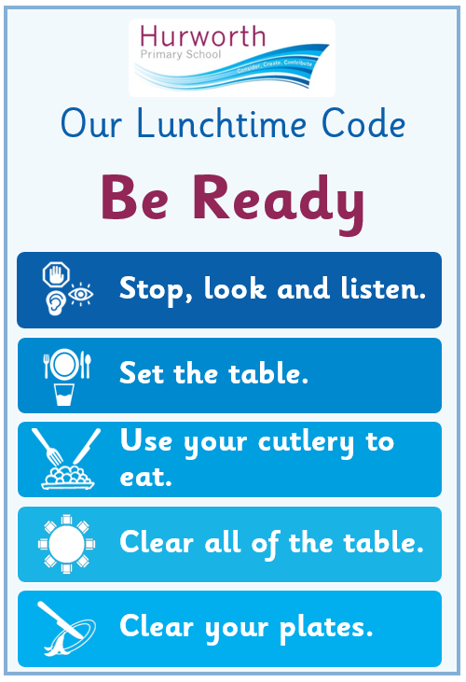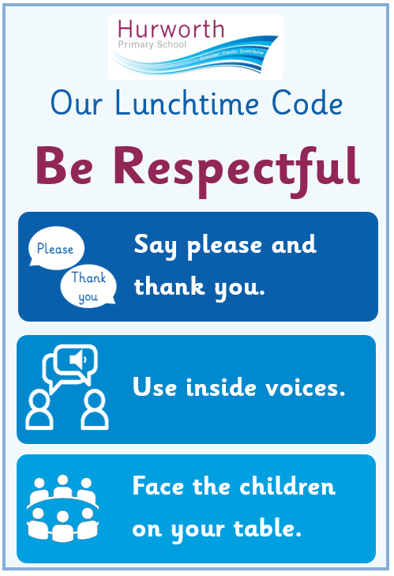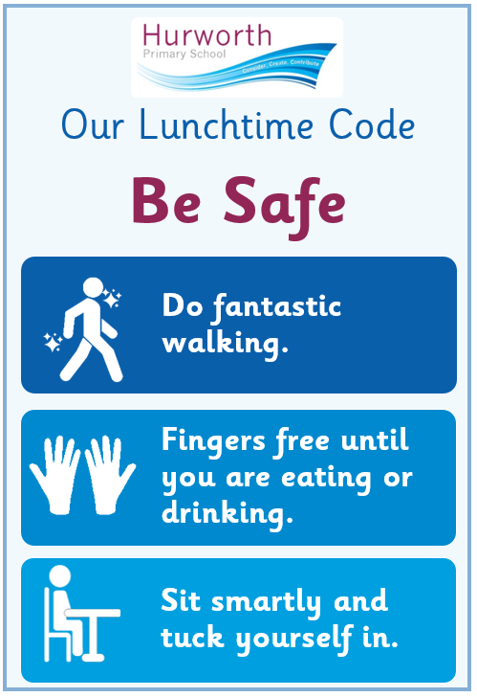

**Appendix 2:**

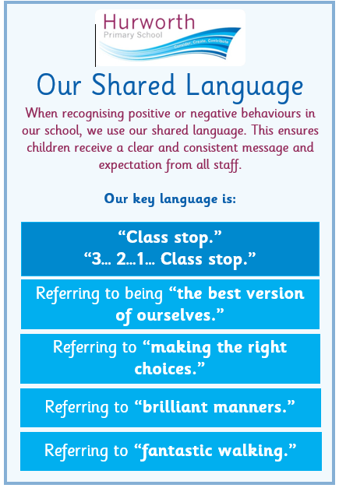

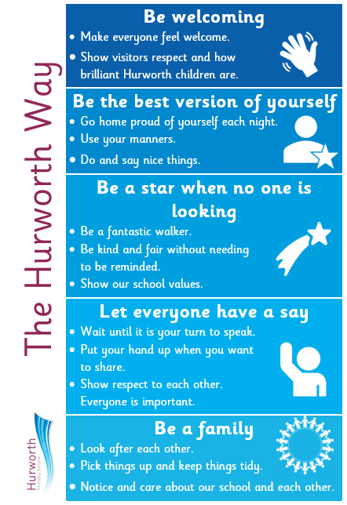

**Appendix 3:**

**Classroom Routines**

These routines will be consistently used within the classroom to ensure all children understand how they are expected to behave by all adults.

**Setting the Class to Work Routine**

When setting children on a task, it is important that the children know exactly what is expected of them. When explaining, consider:

* Time allowed and task set
* Resources required – have them ready
* Outcomes that the children need to meet
* Grouping organised – after the task is set
* Stop signal made clear

For more information, see page 78 in ‘When the Adults Change, Everything Changes’ book.

**Our Listening Code**

When adults in school require the attention of the class, they will ping the bell followed by saying ‘Class stop’.

When this happens, we:

* Stop what we are doing
* Empty hands/fingers free (Reception and KS1)
* Look at the teacher
* Keep quiet and still
* Listen to instructions

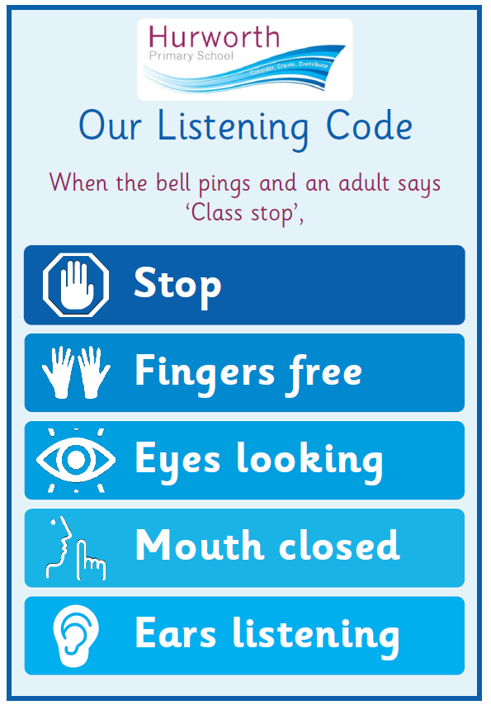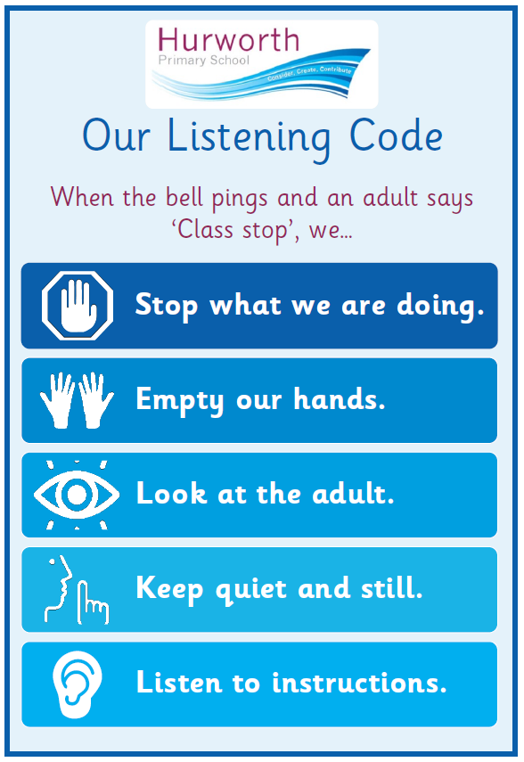

**Classroom Routines**

In their own classroom, teachers have clear, thought out routines for:

* Where children put their bag and belongings
* What children need on their desks at the beginning of the day to avoid excessive movement of all children together
* Where children put their coats and how you will manage them all needing coats at the same time
* Going to the toilet. You must have a procedure in place so that you know who is where at all times.
* What goes where! An unorganised classroom can affect excellent behaviours and routines
* How Reception and KS1 children will transition from and to carpet spots using the 1, 2, 3 approach
  1. Stand up (whole class or specific groups)
  2. Walk sensibly to tables/activities
  3. Sit down and begin task

**Appendix 4:**

**Tool box to support de-escalation techniques**

|  |  |
| --- | --- |
| Fresh face | Move back out of immediate range and let other staff/children become the focus |
| Reassurance | “I’ll always try to be here if you need me”  “Although that was wrong, we can help you put things right again” |
| Success reminder | “Remember that excellent number work you did for me this morning…” |
| CALM talking | In any potential confrontation, the first person who needs to calm down is the responsible adult.  Staff must maintain personal control.  Lower voice to help show that you are in control. |
| Distraction | Talk about something totally different (i.e. next weekend) to the child, or to another person.  Bring in something personal such as, “When I was talking to your mum, on the phone…”  “Did you see … last night?”  “Would you like a drink of water?” |
| Contingent touch | Sometimes a gentle touch on the forearm, hand, shoulder, etc. works wonders. Any specialised touch or stroke needs to be formalised in the pupil’s Care Plan and signed by parent. |
| Reflective listening | “Focus on ‘feeling’ words….   * Note general content of message * Observe body language * Ask yourself, “If I were having that experience right now, what would I be feeling?” * Reflect meanings. “You feel….because… |
| Humour | “Did you hear the one about…?” Knock knock.. |
| Planned Ignoring | If it isn’t upsetting anyone else…  Give a child ‘quiet time’ with no interaction other than reflection |
| Withdrawal offered | “Why don’t you go and finish that work in the library…” |
| Emphasise concern for welfare | “Are you alright? … Show me that hurt finger…oooh that must hurt a lot… Did you have a nice tea last night? |
| Help Script | ‘’Name’, I can see you’re upset/ angry …I’m here to help. Come with me. You talk, I’ll listen ‘’ |

**Appendix 5:**

Individual Behaviour Plan

|  |  |  |  |  |
| --- | --- | --- | --- | --- |
| **Preferred Supportive Strategies (Number in order of preference)** | | | | |
| Verbal advice & support- using visuals |  | Contingent touch | |  |
| Reassurance |  | Planned ignoring | |  |
| C.A.L.M talking & stance |  | Time out offered | |  |
| Time out directed |  | Fresh face | |  |
| Humour |  | Choices/Limits/consequences | |  |
| Negotiation |  | Space given | |  |
| Step away |  | Reflective listening | |  |
| Success reminder |  | 3part assertive message | |  |
| Distraction(Key words/objects/likes) |  | Antiseptic bounce | |  |
| **Brief description of supportive strategies e.g. agreed use of language/consequences etc.** | | | | |
| **Preferred Handling Strategies (where necessary)** | | | | |
| Caring C’s |  | Wrap hug standing/seated | |  |
| Friendly hold |  | Double elbow stood/seated | |  |
| Single elbow stood/seated |  | Half-shield | |  |
| Figure of four |  |  | |  |
| **Comments and reasons for use, stating preferred staff and get-outs:** | | | | |
| **Pupil Voice:**  **Things that make me feel these feelings:** | | | | |
| **Happy-** | | | | |
| **Sad-** | | | | |
| **Angry-** | | | | |
| **Nervous/worried/scared/stressed-** | | | | |
| **When I am not happy, I-**  **I would like adults to help me by-** | | | **When I am sad, I-**  **I would like adults to help me by-** | |
| **When I am angry, I-**  **I would like adults to help me by-** | | | **When I am nervous/worried/scared, I-**  **I would like adults to help me by-** | |

**Appendix 7**

Issue Slip

|  |
| --- |
| **Issue Slip**  Diagram  Description automatically generatedSadly, today there has been an incident which we feel you need to know about. We do not expect you to provide a consequence at home, but we feel that you need to know about this incident so that you can talk to your child about making a different behaviour choice next time. Thank you.  Name: Date: Adult:  Incident Description:  If a member of staff hasn’t spoken to you already, we do / do not need you to contact us at a time to suit you |

**Appendix 8**

|  |  |  |  |
| --- | --- | --- | --- |
| **Hurworth Primary School Behaviour Blueprint** | | | |
| **School Rules** | **Key Language** | **Key Routines** | **Rewards** |
| 1. **Be ready:** I will help myself and others to learn 2. **Be respectful:** I will respect the building, staff and other children 3. **Be safe:** I will look after myself and others | * Class Stop (3, 2, 1, Stop) * Referring to being a ‘good person’ and ‘doing the right thing’ * Brilliant manners * Fantastic walking * The Hurworth Way | * Consistent arrivals * Fantastic walking * Lining up * Listening code | * Stickers * Stamps * Steps to Success * Recognition Board * Wows * Pupil of the Week |
| **Stepped Classroom Approach** | | | **Repair Questions** |
| gentle approach, child’s name, child level, eye contact, deliver message | | | ***1. What happened?***  *2. What were you thinking at the time?*  ***(How XXX were you at the time, out of 10?)***  *3. What have you thought since?*  *4. How did that make people feel?*  ***5. Who has been affected (hurt/ upset for KS1)?***  *6. How have they been affected?*  ***7. What should we do to put things right?***  *8. How can we do things differently in the future?*  Number of questions to be used depends on age of child. **Bold** to be used with youngest children. |
| 1. **REMINDER (reinforce 3 rules privately if possible):**  *I noticed you chose to ...... (noticed behaviour). This is a REMINDER that we need to Be (Ready, Respectful, Safe). You now have the chance to make a better choice. Thank you for listening. (Give child take up time and do not respond)* | | |
| 1. **FINAL WARNING:**  *I noticed you chose to …… (noticed behaviour). This is the second time I have spoken to you.*   *If you choose to break the rules again, you leave me no choice but to ask you to move to……../ move out of the classroom to….., …………. (child's name),*  *Do you remember when ………………………………………. (model of previous good behaviour)? That is the behaviour I expect from you.*  *Think carefully. I know that you can make good choices.*  *Thank you for listening. (Give child take up time and do not respond)* | | |
| 1. **TIME OUT AND REPAIR:** *I noticed you chose to …… (noticed behaviour)*   *You need to…………(describe appropriate place in classroom e.g. reading corner, desk at the back, quiet area etc. or outside of classroom e.g. table in the street, Talking Sofas, Living Room).*  *I will come and speak to you in two minutes.*  *\*DO NOT describe child’s behaviour to other adults in front of the child\**  Use the restorative **repair questions** to follow up the incident, repair relationships and enable the pupil to learn what to do next time  **Record on CPOMs brief details of outcomes for all conversations that lead to an Issue Slip, and for others that are for repeat incidents or concerning / escalating behaviours.** | | |
| **PLAYGROUND TIME OUT**  *You need to:*  *1. Stand by another staff member*  *2. Sit on the bench*  *3. Go inside to......*  *I will come and speak to you in two minutes.* | | |  |