Week 1 | Meat Free Monday | Best of British Tuesday | Around the World Wednesday | Roast Dinner Thursday | Favourites Friday
MEAL CHOICE 1 | Cheese and Tomato Pasta with Garlic Bread and Carrot Batons | Ham, wedges with beans or sweetcorn | Chicken Korma with rice and Naan | Cottage pie with broccoli and carrots | Chicken Goujon wrap with corn on the cob and vegetable sticks
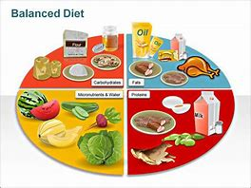  MEAL CHOICE 2 | Tuna and sweetcorn roll with veggie sticks | Cheese roll, wedges and sweetcorn | Jacket potato with cheese and beans | Tuna and cucumber pasta with homemade bread | Mini quiche with corn on the cob and vegetable sticks
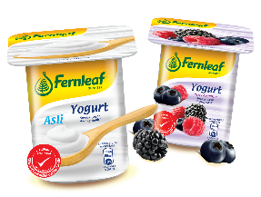 | Yoghurt  or  A selection of seasonal fruit | Cornflake tart and custard  or  Yoghurt  or  A selection of seasonal fruit | Ginger biscuits  or  Yoghurt  or  A selection of seasonal fruit | Yogurt  or  A selection of seasonal fruit | Jelly  or  Yoghurt  or  A selection of seasonal fruit
**All dietary requirements will be catered for, i.e. vegetarian, lactose or dairy free etc…

Week 2 | Meat Free Monday | Best of British Tuesday | Around the World Wednesday | Roast Dinner Thursday | Favourites Friday
MEAL CHOICE 1 | Homemade cheese and tomato pizza wrap with veggie sticks | Chicken burger in a wholemeal bun with chunky chips | Pasta Bolognese with homemade bread | Roast chicken dinner with homemade yorkshire puddings, roast potatoes, | Sausage in a bun, hash browns, beans or peas
MEAL CHOICE 2 | Vegetable burger in a bun with veggie sticks | Ham roll with chunky chips with cucumber sticks | Jacket potato with cheese and beans | Cheese and ham pasta with cherry tomatoes | Cheese and potato pie, hash brown and beans or peas
 | Yoghurt  or  A selection of seasonal fruit | Ginger cake and custard  or  Yoghurt  or  A selection of seasonal fruit | Chocolate and orange cake  or  Yoghurt  or  A selection of seasonal fruit | Yoghurt  or  A selection of seasonal fruit | Carrot cake  or  Yoghurt  or  A selection of seasonal fruit
Week 3 | Meat Free Monday | Best of British Tuesday | Around the World Wednesday | Roast Dinner Thursday | Favourites Friday
MEAL CHOICE 1 | Sea stars, wedges with beans or peas | Hot turkey baguette (with stuffing) with roasted new potatoes and carrot batons | BBQ Fajitas with tortilla chips and sweetcorn | Sausage, mash, peas, carrots and gravy | Wholemeal cheese and tomato pizza with beans or cucumber
MEAL CHOICE 2 | Cheese roll, wedges and cherry tomatoes | Corned beef pie with roasted new potatoes and carrot batons | Jacket potato with cheese and beans | Chicken and sweetcorn pasta with vegetable sticks | Ham baguette with beans or cucumber
 | Yoghurt  or  A selection of seasonal fruit | Beetroot chocolate cake and custard  or  Yoghurt  or  A selection of seasonal fruit | Apple and cinnamon cookies  or  Yoghurt  or  A selection of seasonal fruit | Yoghurt  or  A selection of seasonal fruit | Lemon and white chocolate muffin  or  Yoghurt  or  A selection of seasonal fruit
**All dietary requirements will be catered for, i.e. vegetarian, lactose or dairy free etc…

